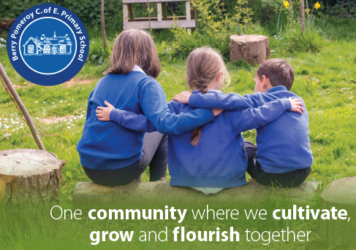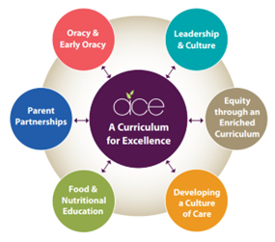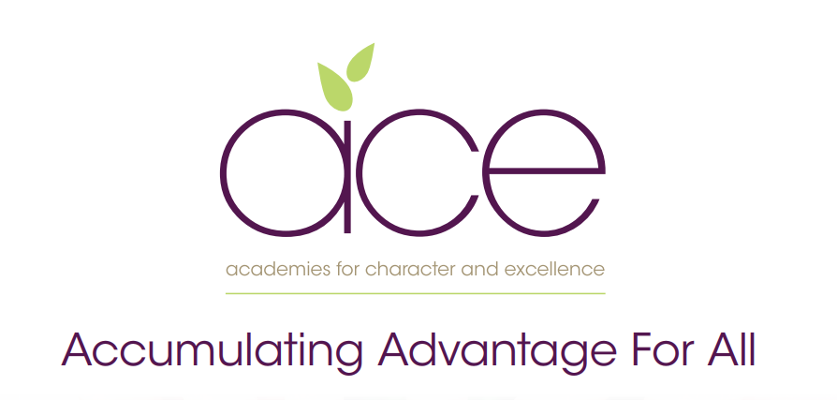

**Berry Pomeroy’s Pupil premium strategy statement**

**2024–2027**

This statement details our school’s use of pupil premium (and recovery premium for the 2024 to 2027 academic year) funding to help improve the attainment of our disadvantaged pupils. It outlines our pupil premium strategy, how we intend to spend the funding in this academic year and the effect that last year’s spending of pupil premium had within our school. 

**School overview**

|  |  |
| --- | --- |
| **Detail** | **Data** |
| School name | Berry Pomeroy |
| Number of pupils in school | 89 |
| Proportion (%) of pupil premium eligible pupils | 10.11% |
| Academic year/years that our current pupil premium strategy plan covers **(3 year plans are recommended)** | 2024–2027 |
| Date this statement was published | September 2024 |
| Date on which it will be reviewed | July 2027 |
| Statement authorised by | Interim advisory board |
| Pupil premium lead | Jess Bowden Headteacher |
| Governor / Trustee lead | Sophie Lee |

**Funding overview**

|  |  |  |
| --- | --- | --- |
| **Detail** | | **Amount** |
| Pupil premium funding allocation this academic year 2022/2023 | £ 2530 per child | |
| Recovery premium funding allocation this academic year |  | |
| Pupil premium funding carried forward from previous years (enter £0 if not applicable) | £0 | |
| **Total budget for this academic year**  If your school is an academy in a trust that pools this funding, state the amount available to your school this academic year | £ 22,770 | |

**Part A: Pupil premium strategy plan**

|  |
| --- |
| * *See our Trust wide plan* ***‘Accumulating Advantage for all’***   In a changing world we recognise the need to ensure that our Curriculum reflects how pupils are supported and encouraged to flourish in all aspects of their lives. Current research shows that the South West is one of the most challenging areas to grow up poor. We strongly believe that as a Trust, and through our curriculum, we are able to narrow the disadvantaged gap, supporting all pupils. |

**Our aims for our disadvantaged pupils**

* Our aim as a Trust is to ensure that all pupils accumulate advantage, based on the high-quality experience that we offer them through our curriculum and enquiry-based approach to learning.
* Our curriculum is rich and ambitious and offers all pupils an equal opportunity to experience a range of outdoor lessons, take part in educational visits, theatre trips, hands-on days, expert visits and have the opportunity to explore a wide range of extra-curricular clubs.
* We believe that all pupils should have the opportunity to aspire to be the best version of themselves. Therefore, we provide pupils with the experiences that develop their love of learning and support them to acquire experiences as they move through their school lives, to make informed life choices.

**Statement of Intent**

At the heart of our curriculum lie three core values: pursuit of academic excellence; the explicit teaching of learning to learn, which includes the development of metacognition; and, crucially, character education. We believe that through our curriculum and core principles we can ensure that our very high expectations result in improved outcomes for disadvantaged pupils. This ensures all children will achieve and flourish whilst acquiring life-long skills that enable learners to overcome any barriers to learning and future successes.

**Objectives for our disadvantaged pupils**

* We will ensure that the progress of our disadvantaged children will equal or exceed the progress of those who are not disadvantaged by implementing our strategy plan. The ACE curriculum plays a central and critical role in accumulating advantage for all pupils, including those that are presently experiencing or have experienced disadvantage.
* All disadvantaged pupils will be equipped academically, socially, culturally and emotionally to continue to make progress at their secondary schools and beyond. Our aim is to ensure that all children leaving our schools are successful learners, curious explorers and healthy thinkers.

**Our current pupil premium plan focuses on the following goals**

(***see ‘Accumulating advantage for all’*** booklet for more detail)

Strong leadership that drives:

* Equity through an enriched curriculum (including high-quality, well-researched and impactful interventions)
* A culture of high-quality care
* Food and nutrition education
* Effective parent/carer partnerships
* Development of early oracy and ongoing oracy skills

**Our strategy plan is based on the following key principles**

* The plan is a key tool for improving outcomes for our disadvantaged pupils.
* It is aligned with and integral to other school plans and process. It forms part of the school’s wider planning and staff are familiar with it.
* Working to improve provision for our disadvantaged pupils should also improve provision for the wider school community, including for pupils who are not eligible for the Pupil Premium but whose needs are similar.
* Continuing professional development of different types forms an important strand of this work.
* This three-year plan can be adjusted in the light of evidence, including our own evaluation of what has worked (or not) in previous years.
* Regular reviews and scrutiny of data are seen as essential in evaluating the extent to which the plan is on track to meet its three-year objectives.
* We aim to provide value for money in terms of using our pupil premium (and recovery) funding efficiently and effectively to benefit our disadvantaged pupils.

**Challenges**

This details the key challenges to achievement that we have identified among our disadvantaged pupils.

|  |  |
| --- | --- |
| **Challenge number** | **Detail of challenge** |
| 1 | Many children have weak oral language skills on entry, including limited vocabulary, affecting their spoken language, comprehension and, later, their writing. |
| 2 | Covid-19 lockdowns negatively affected children’s knowledge and skills in English and mathematics (lost learning) and exacerbated existing difficulties. |
| 3 | For some children, their social, emotional and mental health (SEMH) needs negatively affect their learning. |
| 4 | Some children lack resilience for learning and, during Covid-19 lockdowns, lost the resilience they had gained. |
| 5 | Lack of parental support and their lack of knowledge about how to provide such support for their children are barriers to the progress of some children. |
| 6 | Poor attendance and punctuality are barriers for some children. |

**Intended outcomes  *- see ‘Accumulating Advantage for all’***

|  |  |
| --- | --- |
| **Intended outcome** | **Success criteria** |
| * **A Curriculum for Excellence**   The ACE curriculum is ensuring QFT is making a difference for our disadvantaged pupils and progress measures show the gap between disadvantaged and others is closing | * 100% of all pupils meet the threshold of the phonic screening check by 2027 * Spelling scores show year on year improvement in KS1 GPaS test * Gap between PP and non-PP reduces each year in GPaS. * KS1 teacher assessment: reading   95% of PP pupils working at the expected standard by 2027   * KS1 teacher assessment: GPaS   95% working at the expected standard by 2027   * KS1 teacher assessment: writing   95% working at the expected standard by 2027   * KS1 teacher assessment: mathematics   95% at the expected standard by 2027  Gap between PP and non-PP reduces year on year in all core subjects   * KS2 national test: reading   100% at the expected standard by 2027   * KS2 national test: GPaS   100% at the expected standard by 2027   * KS2 teacher assessment: writing   100% at the expected standard by 2027   * KS2 national test: mathematics   100% at the expected standard by 2027   * Test data and teacher assessments in English and mathematics (see above) show progress gap narrowing between disadvantaged and other pupils in both Key Stages to be >10%. |
| * **Oracy**   All disadvantaged pupils have a 'flying start’ to their schooling and have improved oracy skills and are increasingly able to communicate effectively through targeted support. | * 100% of PP pupils achieve a good level of development in C&L by 2027 * 100% of PP pupils achieve a good level of development in Literacy by 2027 |
| * **Enrichment opportunities** are providing pupils with the skills and knowledge to become more successful learners | * All PP pupils attend at least one after-school club by 2027. * All disadvantaged pupils attend residential |
| * **Food and Nutrition**   Pupils and families have opportunities in school to participate in workshops and clubs to improve health through food and nutrition education | * All PP children are well fed in school, they have easy access to food and being hungry is never an issue. |
| * **High-quality care** through SEMH support is ensuring excellent wellbeing and readiness for learning * **Parent/carer partnerships** are strong and parents are increasingly able to support their children’s wellbeing and learning | * Attendance data shows disadvantaged pupils’ attendance improves year on year and closes gap with non-PP pupils. * Family and pupil bi-annual questionnaires provide evidence of effective support |

|  |  |
| --- | --- |
| Intended outcome (recovery funding 2022/2023) | Key Success criteria |
| Professional development for teachers | * Teachers AfL is developed * Teachers identify gaps in the learning * Teachers design schemes of work to meet gaps * Teachers can effectively fill gaps in learning |
| To ensure that all children’s mental health and wellbeing is at the forefront of everything that we do | * Pupils feel that they are supported and challenged in school. * The curriculum has a focus on mental and physical health. * Curriculum focus on peer-on-peer abuse & E-safety |
| To ensure that our curriculum is planned, delivered and assessed in such a way that all children are provided with the opportunities to continue with ‘catching up and recovery’ with any lost learning due to Covid-19, whilst ensuring that they are also able to receive a broad and balanced curriculum that is appropriate to their age and/or ability | * Assessments across the year show that the children are on track to achieve the appropriate end of term expectations * The focus of the curriculum is to ensure that basic gaps are being filled * Effective deployment of staff in KS1 and Early Years groups with well-planned and structured interventions that ensure accelerated progress for identified children |

**Activity in the academic 2024/2025year**

**Teaching (for example, CPD, recruitment and retention)**

Budgeted cost: £10,000

|  |  |  |
| --- | --- | --- |
| Activity | Evidence that supports this approach | Challenge number(s) addressed |
| Training to develop talk in the Early Years (speech and language) | Early Reading framework – Section 2: developing Talk and Appendix 2 | 1,4 |
| Training for new staff members on how to deliver Language Link system (Speech and Language) | EEF – [Oral Language Interventions](https://educationendowmentfoundation.org.uk/education-evidence/teaching-learning-toolkit/oral-language-interventions) | 1 |
| Training for new staff to deliver RWI sessions | Implementing a systematic programme (ERF) | 1 |
| Weekly coaching and training to develop teaching staff’s pedagogy with a focus on assessment for learning. | EEF – [Embedding Formative Assessment](https://educationendowmentfoundation.org.uk/education-evidence/teaching-learning-toolkit/feedback)  EEF – [Metacognition](https://educationendowmentfoundation.org.uk/education-evidence/guidance-reports/metacognition#nav-downloads) | 1,2,3,4 |
| 1:1 coaching for Early Career Teachers and new to trust teachers with SLT. | [Strand 8 Professional Behaviours](https://assets.publishing.service.gov.uk/government/uploads/system/uploads/attachment_data/file/978358/Early-Career_Framework_April_2021.pdf) | 2,3 |
| Supporting Reception class as a mixed-aged class.   * Targeted intervention for Y1 PP children to fill gaps. * Smaller phonics groups for targeted RWI support. | EEF- [Targeted Academic Support](https://educationendowmentfoundation.org.uk/support-for-schools/school-improvement-planning/2-targeted-academic-support) | 1,2 |

**Targeted academic support (for example, tutoring, one-to-one support structured interventions)**

Budgeted cost: £8,000

|  |  |  |
| --- | --- | --- |
| Activity | Evidence that supports this approach | Challenge number(s) addressed |
| 1:1 phonics tutoring | EEF – [one to one tutoring](https://educationendowmentfoundation.org.uk/education-evidence/teaching-learning-toolkit/one-to-one-tuition) | 1,2 |
| Targeted Academic Support – small group intervention 4 x per week in phonics, reading, writing and maths in both KS1 and KS2. | EEF- [Targeted Academic Support](https://educationendowmentfoundation.org.uk/support-for-schools/school-improvement-planning/2-targeted-academic-support) | 1,2 |
|  |  |  |
| 1:1 fluency intervention | EEF – [improving literacy at KS2](https://educationendowmentfoundation.org.uk/education-evidence/guidance-reports/literacy-ks2) | 2 |

**Wider strategies (for example, related to attendance, behaviour, wellbeing)**

Budgeted cost: £4,770

|  |  |  |
| --- | --- | --- |
| Activity | Evidence that supports this approach | Challenge number(s) addressed |
| Deliver high-quality physical education and Forest School to support mental and physical well-being | EEF – [Physical Activity](https://educationendowmentfoundation.org.uk/education-evidence/teaching-learning-toolkit/physical-activity) & [Self-regulation](https://educationendowmentfoundation.org.uk/education-evidence/guidance-reports/metacognition#nav-downloads) | 2,4 |
| Early Help lead to support families with parenting support, workshops, EWO support and Early Help. | EEF – [parental engagement](https://d2tic4wvo1iusb.cloudfront.net/documents/news/Parental_Engagement_-_Evidence_from_Research_and_Practice.pdf) | 4,5,6 |

**Total budgeted cost: £12,000**

**Part B: Review of outcomes in the previous academic year (2023-24)**

**Pupil premium strategy outcomes**

**Findings relating to our disadvantaged pupils were as follows:**

1. Pupils made strong progress from their starting points across the school in 2023/2024. EYFS GLD was 100% (100%PP), Year 1 phonics screening 94% (100% PP) and Year 6 (94% maths, 100% reading and writing) (100% combined for PP) made excellent progress and attained well as shown from national tests and compared to other schools in Devon (example Year 6).
2. Targeted approach had the greatest impact: small group work before and after school, PE teacher split classes and 1:1 tutoring sessions, high quality pastoral care
3. Family and pupil surveys show that they feel safe, supported and happy with the school’s offer.

The findings confirm the positive direction of our current three-year strategy. As a result, we are investing further in 1:1/small group interventions,. There will be a key focus on improving attendance through a whole-school systematic approach.’